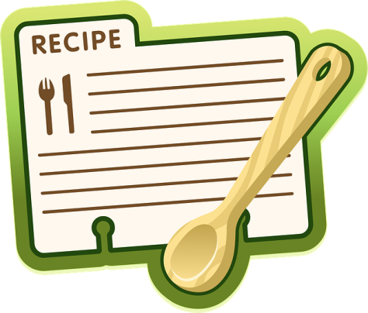

Newton at Home Members, Volunteers and Friends-

On the occasion of our fifth birthday, we are pleased to announce the
Newton at Home Cookbook Project!

Please consider contributing a recipe - ideally one that you make often and that gets rave reviews. There are several ways to get your recipe to us:

- Complete the attached blank form or make a copy of the recipe and return it to us:
  - Mail: Newton at Home, c/o Aileen Murphy, 206 Waltham St. West Newton, MA 02465 or
  - Email: programcoord@newtonathome.org
- Contact the office and we will arrange for a volunteer to come to your home and take a photograph of the recipe or talk with you as you describe the ingredients and the cooking directions.

​Also please let us know if you are willing to make the recipe and we will send a volunteer to your home to take a photograph of your finished dish.

Please also note why this recipe is special to you. ​Is this a family favorite? Have you had it for years? Is this what you bring to potluck suppers and it's a hit? Is it a recipe that came from a loved one?

Proceeds from the sale of the cookbook will ​benefit ​Newton at Home. Please submit your recipe as soon as possible.

We are very excited about this project. It will be a collaborative effort between all of us who make Newton at Home such a vibrant contribution to our city. The cookbook will be ready for sale at our Annual Meeting in October and in time for the 2016 holiday season. Please do not hesitate to contact us with questions.

Warmly,

Carole Noveck, Newton at Home volunteer cegn@rcn.com and 617) 930-3310 working together with

Julie Plaut Mahoney, Coordinator of Partnerships and Volunteers
Aileen Murphy, Program Coordinator
Newton at Home (617) 795-2560
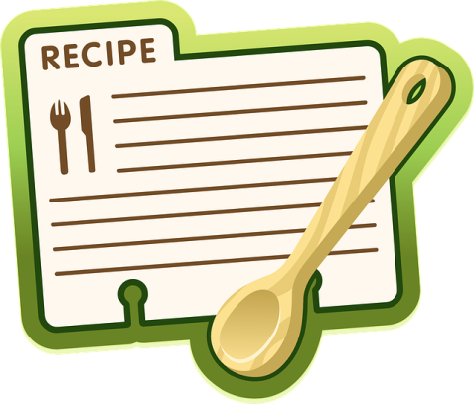
RECIPE FORMAT
TITLE: (include name of contributor and some description of food)
For example: Julie’s Mango Chicken
I love to make this recipe on Friday nights. I always keep the ingredients on hand because I know it’s a crowd pleaser for those nights where I want a little something special without going to a lot of effort. It goes great with egg noodles and green beans or any other green vegetable on the side. A glass of chilled white wine or sparkling cider is a nice complement to this dish.
APPROXIMATE TIMING:
Preparation time:
Cooking time:
SERVING SIZE:
INGREDIENTS:

DIRECTIONS:
(please include any secrets that you use to prepare this recipe.)

